1. Instruction:

The instruction format is divided into 2 modes:

* If D/C is set LOW => Command
* If D/C is set HIGH => Display data, After every data byte the addresss counter is increment automatically.

The MSB is transmitted first

Send a byte to PCD8544:

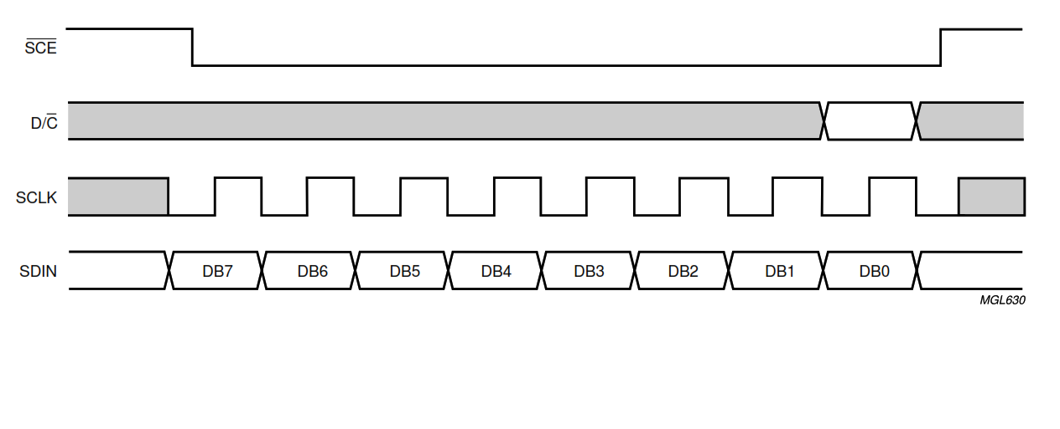

* When SCE is HIGH, SLCK signal is ignored. During the HIGH time of SCE, the serial interface is initialized.
* SDIN is sampled at the positive edge (rising edge) of SCLK.
* D/C indicates whether the byte is a command or display data. It is read with 8th SCLK pluse.
* If SCE stay LOW after last bit of command/data byte. The serial interface expects bit 7 of the next bytes at the next positive edge of SCLK.

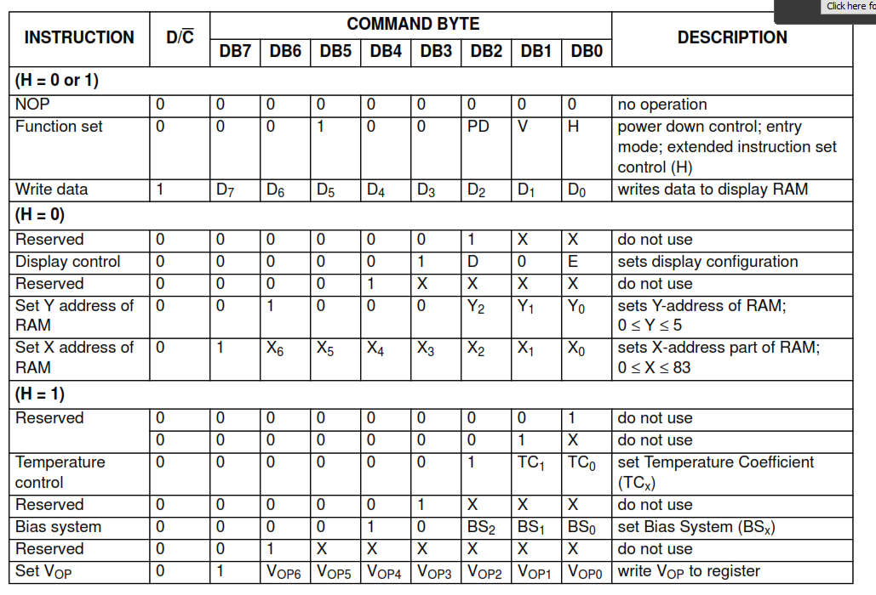

How to use:

1. Reset:

* A reset pluse pulse with RES interrupt the transmission. No data is written to the RAM. The register are cleared.
* If SCE is LOW after positive edge of RES the serial interface is ready to receive bit 7 of a command/data byte.

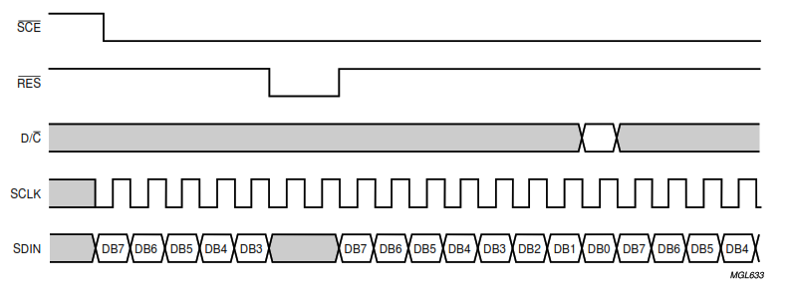

* Step:
  + Set RST & SCE pins
  + Clear RST pin
  + Wait 5ms
  + Set RST pin

1. Clear Screen:

setCursor to 0 , 0

send 0x00, 504 times

1. Begin

* Set H = 1 (0010 0001)
* Set Bias system (0000 1XXX):

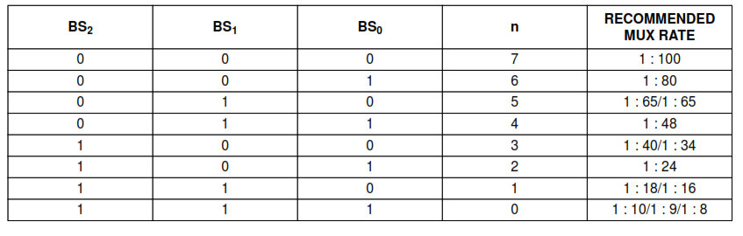

* Set Vop (Contrast of LCD) (1XXX XXXX):

Vop[6:0] = (VLCD  - 3,03) / 0,06.

* Set Temperature Coefficient: (0000 01XX):

|  |  |
| --- | --- |
| TC1 & TC0 |  |
| 00 | Vlcd temperature coeffcient 0 |
| 01 | Vlcd temperature coeffcient 1 |
| 10 | Vlcd temperature coeffcient 2 |
| 11 | Vlcd temperature coeffcient 3 |

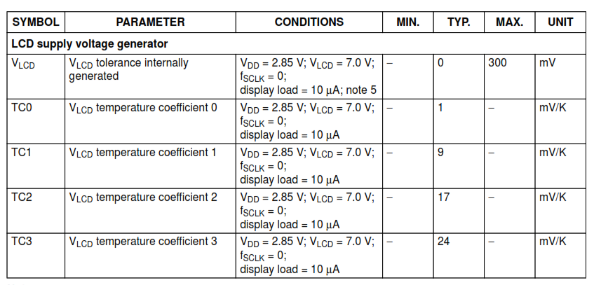

* Set H = 0 (0010 0000)
* Set Display configuration(0000 1D0E):

|  |  |  |
| --- | --- | --- |
| D and E | Modes | Hex Code |
| 00 | Display blank | 0x08 |
| 10 | Normal Mode | 0x0C |
| 01 | All Display Segment On | 0x09 |
| 11 | Inverse Video Mode | 0x0D |

* Set Y address (0100 0XXX)
* Set X address (1XXX XXXX)

1. Send Char

* Width of every character + space after it is 6.
* Step:
  + Send that char by it Hex Code – 0x20
  + Send a space 0x00

1. Send String

* Step:
  + Get length of string.
  + Full up by space if the string’s length < 14.